1. BGP: Consider the network shown. Suppose AS3 and AS2 are running OSPF and AS1, AS4 are running RIP for their intra-AS routing protocol. Which of the routing protocols (OSPF, RIP, eBGP, or iBGP) do the mentioned routers learn the routes?.



y

1. Router 3c learns about prefix y from which routing protocol? - eBGP
2. Router 3a learns about y from which routing protocol? - iBGP or eBGP as per justification
3. Router 1c learns about y from which routing protocol? -eBGP
4. Router 1d learns about y from which routing protocol? -iBGP
5. Lets say 1d uses 1a over 1b. Why would it use that interface and what policy is this router using as per BGP?

ANS: Explain hot potato routing

1. NAT

Consider two hosts connected to a router which is connected to a web server (122.10.5.6). The router is NAT enabled. Ipconfig on host A and host B shows 192.168.1.1 and 192.168.1.2 respectively. The IP address retrieved from “what is my IP” is 14.14.5.1. Answer the following questions in the format:

(SourceIP, DestinationIP, SourcePort#, DestinationPort#)

1. If host A wants connect to the server, what will be the packet contents from host A to router?

ANS: (192.168.1.1, 122.10.5.6, 189, 80)

1. What will be the packet contents from router to the server?

ANS: (14.14.5.1, 122.10.5.6, 100, 80) [Source port # 189 translated to # 100; 192.168.1.1 translated to 14.14.5.1]

1. If host B wants connect to the server, what will be the packet contents from host B to router?

ANS: (192.168.1.2, 122.10.5.6, 990, 80)

1. What will be the packet contents router to the server? (1 point)

ANS: (14.14.5.1, 122.10.5.6, 50, 80) [Source port # 990 translated to # 50, 192.168.1.2 translated to 14.14.5.1]

e) What will be the packet contents from server to client A?

ANS: First server-router; then router-Client A

I: (122,10.5.6, 14.14.5.1, 80, 100)

II; (122,10.5.6, 192.168.1.1, 80, 189) [destination port # 100 translated back to # 189]

1. Consider the topology diagram shown.

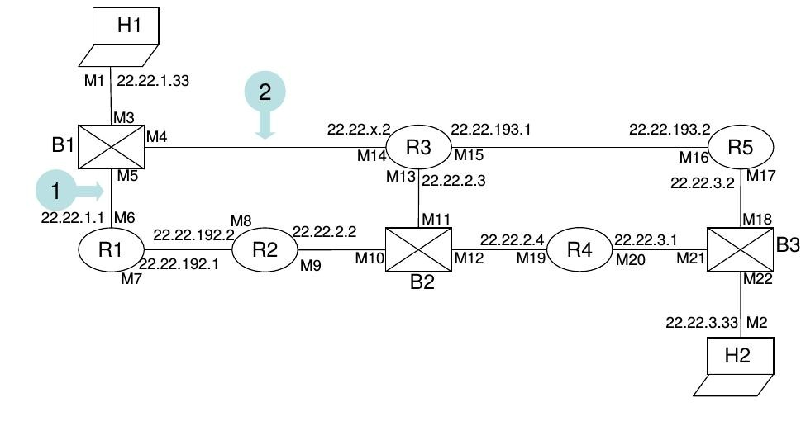

All links are Ethernet cables. B1 to B3 are switches (they are manageable switches, hence have MAC address, but this will not make a difference in this problem. The MAC addresses indicated as M1 to M22. ). R1 to R5 are routers. H1 and H2 are hosts All interfaces are configured with network mask 255.255.255.0. All routers run a distance vector routing protocol.

Routers connected through switches are considered to be neighbors (for e.g., R2-B2-R3, R2-B2-R4, R3-B2-R4, R1-B1-R3). The link costs are the same in both directions and are configured as follows.

R1-R3:10

R1-R2:1

R2-R3:1

R2-R4:1

R3-R4:1

R3-R5:10

R4-R5:1

Assume that the costs given above are the costs to reach the specific networks.

(a) Give a possible value of the routing table entry at each router (give the IP address of the router) for destination network 22.22.3/24, assuming the routing protocol has converged. Write down the values using the format below. If its a direct connection, write DIRECT in Next Hop column. (10 marks, 2 marks for each row)

At Router Next Hop Distance

1. R1
2. R2
3. R3
4. R4
5. R5

(b) The link between R2 and B2 fails. Fill in the table below with new costs for the destination network 22.22.3/24 (10 marks).

At Router Next Hop Distance

1. R1
2. R2
3. R3
4. R4
5. R5